**Arduino Basic Projects**

**#1 – Test Arduino**

The first project is one of the most basic and simple circuits you can create with Arduino.  This project will test your Arduino by blinking an LED that is connected directly to the board.

**Parts Needed**

* (1) Arduino Uno
* (1) USB A-to-B Cable
* (1) LED 5mm
* (1) 220 Ω Resistor

**Project Diagram**

[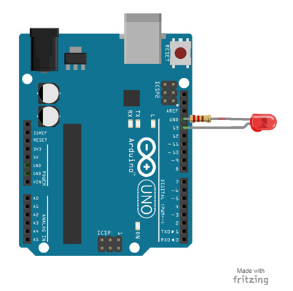](https://www.makerspaces.com/wp-content/uploads/2017/05/1-Test-Arduino_-LARGE.jpg)

**Project Steps**

1. Twist a 220 Ω resistor to the long leg (+) of the LED.
2. Push the short leg of the LED into the ground (GND) pin on the board.
3. Push the resistor leg that’s connected to the LED into the #13 pin.

**Project Code**

1. Connect the Arduino board to your computer using the USB cable.
2. Open project code  –  **Circuit_01_TestArduino**
3. Select the board and serial port as outlined in earlier section.
4. Click upload button to send sketch to the Arduino.

**#2 – Blink an LED**

This project is identical to project #1 except that we will be building it on a breadboard.  Once complete, the LED should turn on for a second and then off for a second in a loop.

**Parts Needed**

* (1) Arduino Uno
* (1) USB A-to-B Cable
* (1) Breadboard – Half Size
* (1) LED 5mm
* (1) 220 Ω Resistor
* (2) Jumper Wires

**Project Diagram**

[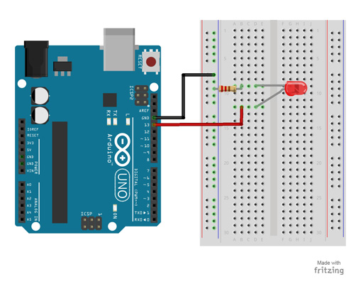](https://www.makerspaces.com/wp-content/uploads/2017/05/2-Blink-an-LED_LARGE.jpg)

**Project Code**

1. Connect the Arduino board to your computer using the USB cable.
2. Open project code  –  **Circuit_02_Blink**
3. Select the board and serial port as outlined in earlier section.
4. Click upload butt000q bon to send sketch to the Arduino.

**#3 – Push Button**

Using a push button switch, you will be able to turn on and off an LED.

**Parts Needed**

* (1) Arduino Uno
* (1) USB A-to-B Cable
* (1) Breadboard – Half Size
* (1) LED 5mm
* (1) 220 Ω Resistor
* (1) 10K Ω Resistor
* (1) Push Button Switch
* (6) Jumper Wires

**Project Diagram**

[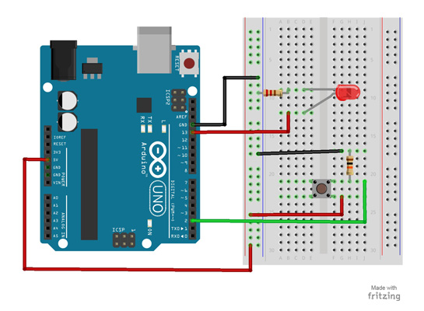](https://www.makerspaces.com/wp-content/uploads/2017/05/3-Pushbutton_LARGE.jpg)

**Project Code**

1. Connect the Arduino board to your computer using the USB cable.
2. Open project code  –  **Circuit_03_Pushbutton**
3. Select the board and serial port as outlined in earlier section.
4. Click upload button to send sketch to the Arduino.

**#4 – Potentiometer**

Using a potentiometer, you will be able to control the resistance of an LED.  Turning the knob will increase and decrease the frequency the LED blinks.

**Parts Needed**

* (1) Arduino Uno
* (1) USB A-to-B Cable
* (1) Breadboard – Half Size
* (1) LED 5mm
* (1) 220 Ω Resistor
* (1) Potentiometer (10k Trimpot)
* (6) Jumper Wires

**Project Diagram**

[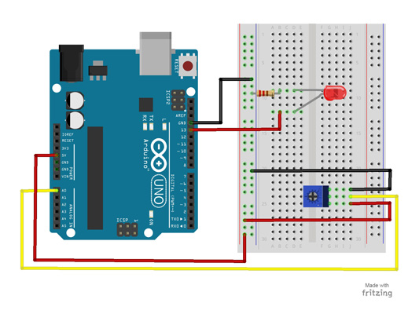](https://www.makerspaces.com/wp-content/uploads/2017/05/4-Potentiometer_LARGE.jpg)

**Project Code**

1. Connect the Arduino board to your computer using the USB cable.
2. Open project code  –  **Circuit_04_Potentiometer**
3. Select the board and serial port as outlined in earlier section.
4. Click upload button to send sketch to the Arduino.

**#5 – Fade an LED**

By using a PWM pin on the Arduino, you will be able to increase and decrease the intensity of brightness of an LED.

**Parts Needed**

* (1) Arduino Uno
* (1) USB A-to-B Cable
* (1) Breadboard – Half Size
* (1) LED 5mm
* (1) 220 Ω Resistor
* (2) Jumper Wires

**Project Diagram**

[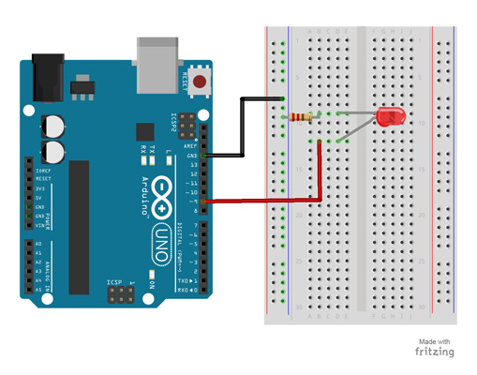](https://www.makerspaces.com/wp-content/uploads/2017/05/5-Fade-an-LED_LARGE.jpg)

**Project Code**

1. Connect the Arduino board to your computer using the USB cable.
2. Open project code  –  **Circuit_05_Fade**
3. Select the board and serial port as outlined in earlier section.
4. Click upload button to send sketch to the Arduino.

**#6 – Scrolling LED**

This project will blink 6 LEDs, one at a time, in a back and forth formation.  This type of circuit was made famous by the show Knight Rider which featured a car with looping LEDs.

**Parts Needed**

* (1) Arduino Uno
* (1) USB A-to-B Cable
* (1) Breadboard – Half Size
* (6) LED 5mm
* (6) 220 Ω Resistor
* (7) Jumper Wires

**Project Diagram**

[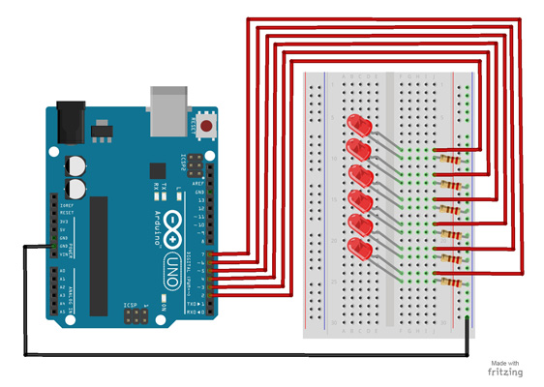](https://www.makerspaces.com/wp-content/uploads/2017/05/6-For-Loop-Scrolling-LED_LARGE.jpg)

**Project Code**

1. Connect the Arduino board to your computer using the USB cable.
2. Open project code  –  **Circuit_06_Scrolling**
3. Select the board and serial port as outlined in earlier section.
4. Click upload button to send sketch to the Arduino.

**#7 – Bar Graph**

Using a potentiometer, you can control a series of LEDs in a row.  Turning the potentiometer knob will turn on or off more of the LEDs.

**Parts Needed**

* (1) Arduino Uno
* (1) USB A-to-B Cable
* (1) Breadboard – Half Size
* (1) Potentiometer – Rotary
* (10) LED 5mm
* (10) 220 Ω Resistor
* (11) Jumper Wires

**Project Diagram**

[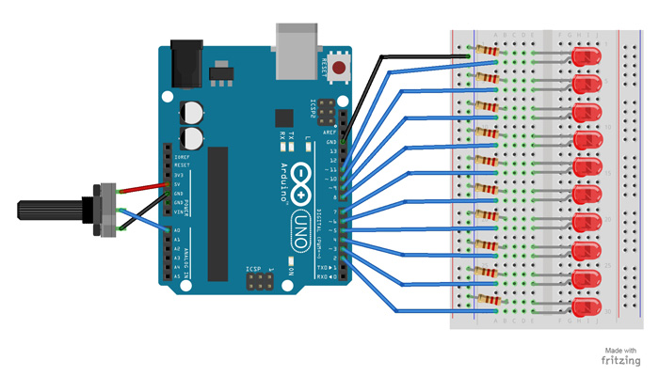](https://www.makerspaces.com/wp-content/uploads/2017/05/7-Bar-Graph_LARGE.jpg)Click Image To Enlarge

**Project Code**

1. Connect the Arduino board to your computer using the USB cable.
2. Open project code  –  **Circuit_07_BarGraph**
3. Select the board and serial port as outlined in earlier section.
4. Click upload button to send sketch to the Arduino.

**#8 – Multiple LEDs**

This project will use 8 pins on the Arduino board to blink 8 LEDs at the same time.

**Parts Needed**

* (1) Arduino Uno
* (1) USB A-to-B Cable
* (1) Breadboard – Half Size
* (8) LED 5mm
* (8) 330 Ω Resistor
* (9) Jumper Wires

**Project Diagram**

[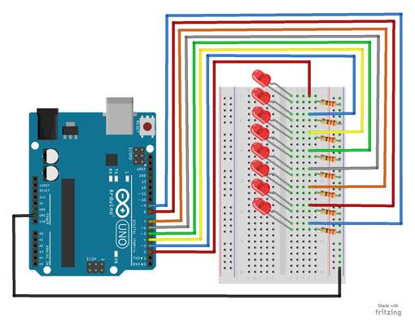](https://www.makerspaces.com/wp-content/uploads/2017/05/8-Multiple-LEDs_LARGE.jpg)

**Project Code**

1. Connect the Arduino board to your computer using the USB cable.
2. Open project code  –  **Circuit_08_MultipleLEDs**
3. Select the board and serial port as outlined in earlier section.
4. Click upload button to send sketch to the Arduino.

**#9 – RGB LED**

This project will be using an RGB LED to scroll through a variety of colors.  RGB stands for Red, Green and Blue and this LED has the ability to create nearly unlimited color combinations.

**Parts Needed**

* (1) Arduino Uno
* (1) USB A-to-B Cable
* (1) Breadboard – Half Size
* (1) RGB LED
* (3) 330 Ω Resistor
* (5) Jumper Wires

**Project Diagram**

[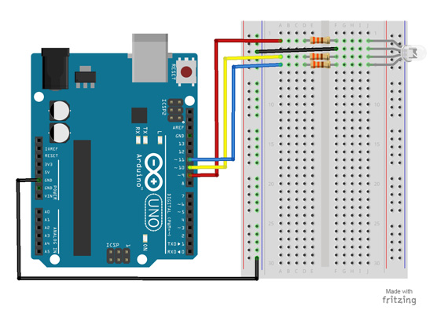](https://www.makerspaces.com/wp-content/uploads/2017/05/9-RGB-LED_LARGE.jpg)Click Image To Enlarge

**Project Code**

1. Connect the Arduino board to your computer using the USB cable.
2. Open project code  –  **Circuit_09_RGBLED**
3. Select the board and serial port as outlined in earlier section.
4. Click upload button to send sketch to the Arduino.

**#10 – Photoresistor**

A photoresistor changes the resistance a circuit gets based on the amount of light that hits the sensor.  In this project, the brightness of the LED will increase and decrease based on the amount of light present.

**Parts Needed**

* (1) Arduino Uno
* (1) USB A-to-B Cable
* (1) Breadboard – Half Size
* (1) LED 5mm
* (1) 330 Ω Resistor
* (1) 10K Ω Resistor
* (1) Photoresistor
* (6) Jumper Wires

**Project Diagram**

[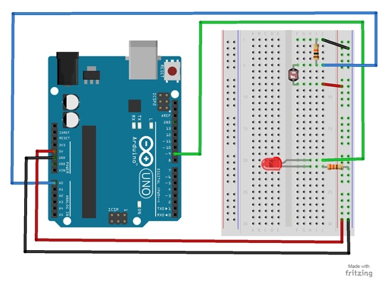](https://www.makerspaces.com/wp-content/uploads/2017/05/10-Photoresistor_LARGE.jpg)

**Project Code**

1. Connect the Arduino board to your computer using the USB cable.
2. Open project code  –  **Circuit_10_Photoresistor**
3. Select the board and serial port as outlined in earlier section.
4. Click upload button to send sketch to the Arduino.

**#11 – Temp. Sensor**

A temperature sensor measures ambient temperatures of the world around it.  In this project, we will be displaying the temperature in the serial monitor of the Arduino IDE.

**Parts Needed**

* (1) Arduino Uno
* (1) USB A-to-B Cable
* (1) Breadboard – Half Size
* (1) Temperature Sensor – TMP36
* (5) Jumper Wires

**Project Diagram**

[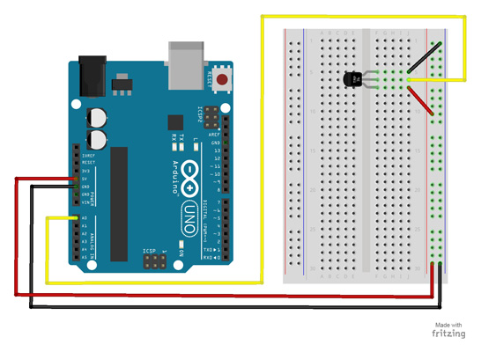](https://www.makerspaces.com/wp-content/uploads/2017/05/11-Temp-Sensor_LARGE.jpg)

**Project Code**

1. Connect the Arduino board to your computer using the USB cable.
2. Open project code  –  **Circuit_11_TempSensor**
3. Select the board and serial port as outlined in earlier section.
4. Click upload button to send sketch to the Arduino.

**#12 – Tone Melody**

The project will use a piezo buzzer/speaker to play a little melody.

**Parts Needed**

* (1) Arduino Uno
* (1) USB A-to-B Cable
* (1) Breadboard – Half Size
* (1) Piezo Buzzer/Speaker
* (2) Jumper Wires

**Project Diagram**

[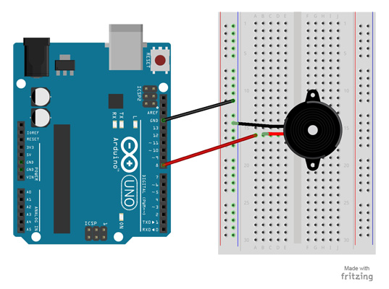](https://www.makerspaces.com/wp-content/uploads/2017/05/12-Tone-Melody_LARGE.jpg)

**Project Code**

1. Connect the Arduino board to your computer using the USB cable.
2. Open project code  –  **Circuit_12_ToneMelody**
3. Select the board and serial port as outlined in earlier section.
4. Click upload button to send sketch to the Arduino.

**#13 – Servo**

In this project, you will be able to sweep a servo back and forth through its full range of motion.

**Parts Needed**

* (1) Arduino Uno
* (1) USB A-to-B Cable
* (1) Breadboard – Half Size
* (1) Servo
* (6) Jumper Wires

**Project Diagram**

[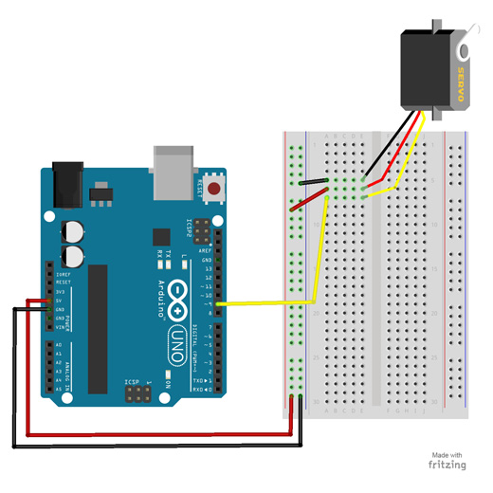](https://www.makerspaces.com/wp-content/uploads/2017/05/13-Servo_LARGE.jpg)

**Project Code**

1. Connect the Arduino board to your computer using the USB cable.
2. Open project code  –  **Circuit_13_Servo**
3. Select the board and serial port as outlined in earlier section.
4. Click upload button to send sketch to the Arduino.

**#14 – Motor**

Using a switching transistor, we will be able to control a DC motor.  If everything is connected correctly, you should see the motor spinning.

**Parts Needed**

* (1) Arduino Uno
* (1) USB A-to-B Cable
* (1) Breadboard – Half Size
* (1) DC Motor
* (1) 330 Ω Resistor
* (1) Diode 1N4148
* (1) NPN Transistor
* (6) Jumper Wires

**Project Diagram**

[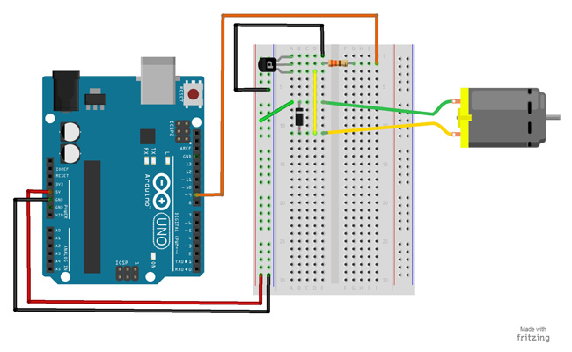](https://www.makerspaces.com/wp-content/uploads/2017/05/14-Motor_LARGE.jpg)

**Project Code**

1. Connect the Arduino board to your computer using the USB cable.
2. Open project code  –  **Circuit_14_Motor**
3. Select the board and serial port as outlined in earlier section.
4. Click upload button to send sketch to the Arduino.

**#15 – LCD Screen**

An LCD is a liquid crystal display that is able to display text on its screen.  In this project, you should see the words “hello,world!” displayed on the screen.  The potentiometer is used to adjust the contrast of the display.

**Parts Needed**

* (1) Arduino Uno
* (1) USB A-to-B Cable
* (1) Breadboard – Half Size
* (1) LCD Screen
* (1) Potentiometer
* (16) Jumper Wires

**Project Diagram**

[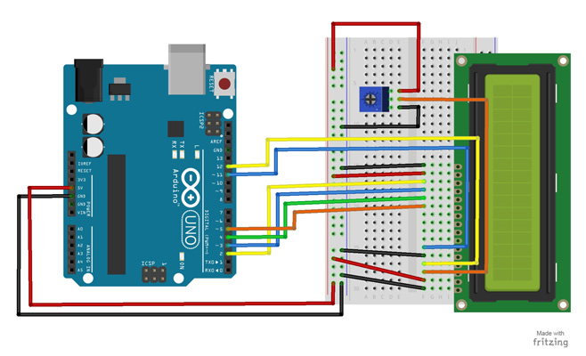](https://www.makerspaces.com/wp-content/uploads/2017/05/15-LCD-Screen_LARGE.jpg)

**Project Code**

1. Connect the Arduino board to your computer using the USB cable.
2. Open project code  –  **Circuit_15_LCD**
3. Select the board and serial port as outlined in earlier section.
4. Click upload button to send sketch to the Arduino.